

Specification

for

Deadlock Alerts

Vicky Harp

7/10/09



Proprietary and Confidential to BBS Technologies, Inc.

© 2006 BBS Technologies, Inc.; all rights reserved.

Revision history:
When? | Who? | What?
7/28/2009 | Vicky Harp | First draft
8/3/2009 | Vicky Harp | Comments included from review
9/25/2009 | Vicky Harp | Added 4.1.6 “Add Servers Wizard”

Table of Contents
1. Revision history: ii
2. Table of Contents ii
3. Requirements 2
3.1. Overview/Purpose 2
3.1.1. Related Customer Requests 2
3.2. Target Users 2
3.3. Use Cases 2
3.4. Feature/Function Market Requirements 3
3.4.1. Required Functions 3
3.4.2. Non-Supported Functions 3
3.5. FAQ 3
3.6. Open Issues 3
4. Functional Design 4
4.1. User Interfaces 4
4.1.1. Server Properties 4
4.1.2. Server Properties 5
4.1.3. Alert Configuration 5
4.1.4. Grooming Options 5
4.1.5. Grooming Options 5
4.2. Installation and Upgrade 5
4.3. Permissions and other Required Configuration 5
4.4. Licensing Issues 5
4.5. Dependencies 6
4.5.1. Dependencies on Idera Software 6
4.5.2. Third-Party Software Required on the Customer Machine 6
4.5.3. Third-Party Software Required Internally 6
5. Internal Design 6
5.1. Architecture 6
5.1.1. Desktop Client 6
5.1.2. Collection Service 6
5.1.3. Management Service 6
5.1.4. Repository 7
5.2. Installation Issues 7
5.3. Schedule 7
5.3.1. Work Breakdown and Sizings 7
5.3.2. Areas of Risk 7
6. Quality Assurance Considerations 8
6.1.1. Overview 8
6.1.2. Developer-Created Unit Tests 8
7. Documentation Considerations 8
8. Bibliography 8

Requirements

Overview/Purpose
In response to a number of customer requests, this specification aims to address deadlock monitoring and alerting capabilities for SQLdm.
A deadlock in SQL Server is a special kind of locking problem which is not well captured by our current monitoring techniques. Unlike a regular process block, where a process halts until such time as the requested resource becomes available, a deadlock is caused when two processes request resources in such a way that a circular dependency is created: A is waiting on B and B is waiting on A. SQL Server maintains an internal monitor for such dependencies, polling at least every 5 seconds to check to see if such a situation exists. If so, one of the processes is terminated and the remaining sessions are able to proceed. A deadlock may involve one or more sessions (it is possible for a session to deadlock on itself – see bibliography). Here is an example of SQL code which will cause a deadlock:
Session 1:
begin tran
use AdventureWorks
update Person.Address set City = City
waitfor delay '00:00:05'
update HumanResources.Employee set LoginID = LoginID
rollback
Session 2:
begin tran
use AdventureWorks
update HumanResources.Employee set LoginID = LoginID
waitfor delay '00:00:05'
update Person.Address set City = City
rollback
Currently SQLdm keeps track of how many deadlocks occur, but because of the speed with which they are resolved, SQLdm cannot give any data about what processes where involved, nor what resources were involved in the lock. The same problem exists throughout DM for certain other short duration problems in SQL Server, but deadlocks are somewhat unique in that the resolution of the problem – termination of one process – is a performance problem in and of itself.
In SQL 2005 Microsoft added a new trace event that returns detailed information on deadlocks. The deadlock data is provided in an XML file format with an .xdl extension, which may be saved and opened in both Management Studio and Profiler. By tracing for this event, SQLdm may alert on deadlocks as they happen and provide more information about the processes involved. For this release we are only considering making this information available in an alert: in future versions historical deadlock data may be made available in a view.

Related Customer Requests
PR 5662 - Allow automatic tracing of deadlocking and blocking with Worst Performing
PR 13182 - FRQ: Monitor and alert on deadlocks.
PR 12687 - FRQ; Alert to detail which SPIDs are involved in a deadlock

Target Users
This request has come from a number of users and will be useful to a broad segment of SQLdm’s customers.

Use Cases
Enable Deadlock Alerting
- User enables tracing for deadlock events on the Query Monitor pane under Server Properties (see 4.1) This event will be enabled by default and enabled by an upgrade, though the Query Monitor will remain disabled by default and the Query Monitor enable/disable will not be changed by an upgrade.
- User enables the deadlock alert under Alert Configuration. This is enabled by default.
- User chooses whether to attempt name resolution of deadlock resources. This is enabled by default.

Receive Deadlock Alert
- A deadlock occurs and the alert is raised at the end of the next scheduled refresh. The alert text includes instructions on how to locate the full data on the Alerts view. The alert notification is limited to 1024 characters and therefore includes only the following information for as many involved processes as will fit in the space, notably excluding the inputbuffer:
  - SPID
  - Hostname
  - Login Name
  - Client Application
  - Database
Example:
SQL Server instance dmlab04 - A deadlock occurred and SPID 65 was chosen as the deadlock victim.

The full deadlock details are available on the Alerts view in the SQLdm Desktop Client. The following processes were involved in the deadlock:

SPID / Host / User / Database / Application
--------------------------------------------------------------------------------------
65* / VHARPL / REDHOUSE\VSHERROUSE / master / Microsoft SQL Server Management Studio - Query
61 / DMLAB03 / REDHOUSE\VSHERROUSE / master / Microsoft SQL Server Management Studio - Query
55 / DMLAB03 / SA / master / SQLAgent - Job invocation engine

Diagnose Deadlock Alert
- The user opens the SQLdm Desktop Client and selects the deadlock alert in the Alerts view. The user sees the same message as the notification with the option to “View deadlock details”
- The user selects “View deadlock details” either from the context menu of the alert or from the alert details pane. This option takes the place of the “View Real Time View” option for Deadlock alerts. (see 4.1) The deadlock details view is displayed with the following information for involved processes and locks:
  - SPID
  - Hostname
  - Login Name
  - Client Application
  - Database
  - Status
  - Wait Time
  - Wait Resource
  - Transaction Count
  - Input buffer
  - Lock Object
  - Lock Mode
  - Lock Owners
  - Lock Waiters

Export Deadlock Data
- From the Deadlock Details screen, the user presses the “Export XDL” button. The user is able to export the original .xdl file for viewing in Management Studio or SQL Server Profiler.

Modify Deadlock Grooming
- From Tools… Grooming Options, the user modifies the option for “Groom Sessions, Queries, Deadlocks, and History Browser data older than…” to the desired setting.

Feature/Function Market Requirements

Required Functions
- When configured, SQLdm will trace for and alert upon deadlocks for SQL 2005 and above.
- The deadlock trace must obey the advanced filtering (application, database, and SQL text) for the Query Monitor (open to discussion).
- The Query Monitor must be able to run with only deadlock events selected.
- This feature will be compatible with the Start Query Monitor server action.
- The following issues need to be resolved concurrent with this feature:
  - PR 14214 – “Alerts pane takes a very, very long time to refresh when looking at past events on a large repostiory, causes console to use 800 MB ram” -- Alert view needs to be bounded
  - PR 14528 - The Details pane on the Alerts view needs to be resizeable
  - PR 14529 - Add flood control to SMTP notification provider

Non-Supported Functions
- We are not supporting viewing Deadlock Details data anywhere except within the context of an alert. The view displayed is analogous to the Session Details drill-down from the Sessions view, and in this version there is no Deadlocks view from which to drill down. The data will be structured within the repository in a way that should simplify a Deadlocks View in the future, but the view itself is out of scope for this version.
- This feature does not support SQL 2000 – it is for SQL 2005 and above only.
- The deadlock trace will not be limited by the duration, cpu usage, logical disk reads, or physical disk writes filters for the Query Monitor.
- Deadlock data will not be displayed in any sort of graphical or flow chart format. The XDL file may be exported to view this in Profiler or Management Studio.
- The deadlock events will not be filtered at present

FAQ
TBD

Open Issues
Resolved

Functional Design

User Interfaces

Server Properties
The Server Properties / Query Monitor panel will be updated to include the Deadlock event and to include an option to attempt name resolution. The screenshot below will not represent the final layout: the Deadlock section will be more clearly separated from the Worst Performing area.
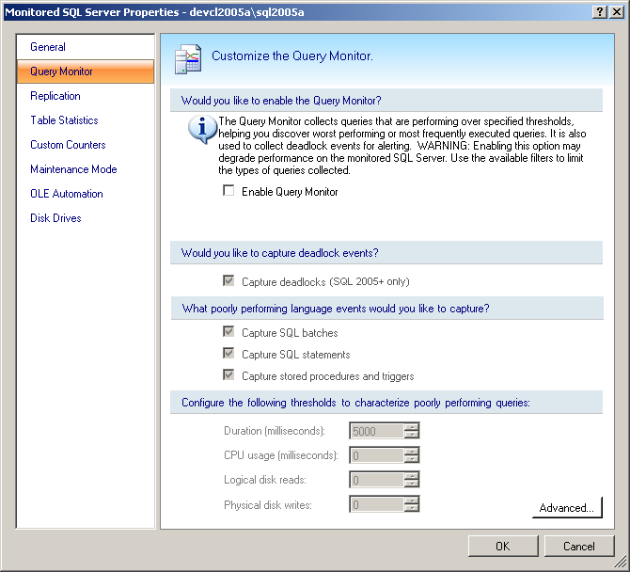

Server Properties
The Alert screen will be modified to replace View Real Time View with View Deadlock Details for Deadlock alerts only. The Details section of the Alerts screen will also be changed such that it is resizable, which will improve usability when reading long deadlock alert messages.
This view will need to be able to handle the use case where an XDL file has been groomed before the corresponding alert.
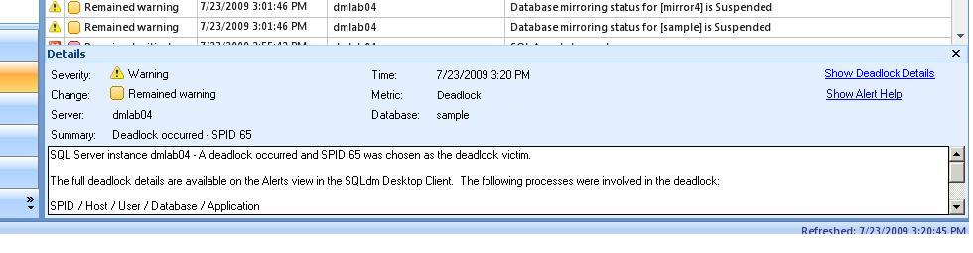

Alert Configuration
The Alert Configuration screen will be updated to include the Deadlock alert. This will be enabled by default and will have no advanced filters, as filtering is handled within the Query Monitor settings.

Grooming Options
The Grooming Options screen will be updated to include Deadlocks in the description of data that is groomed with the Sessions, Queries, and History Browser option.

Deadlock Details View
The Deadlock Details view will be added as a dialog view, similar to Session Details Trace. This view is presently still in the design phase.

Add Servers Wizard
The Add Servers Wizard includes a screen which allows the Query Monitor settings to be configured. The Deadlock event must be added here as well.

Installation and Upgrade
This feature will require a full upgrade of all SQLdm components – repository, desktop client, management service, and collection service.

Permissions and other Required Configuration
This feature will be configurable only by Modify and Administrator users when Application Security is enabled: existing rules to the Server Properties and Alert Configuration views will apply. The alerts will be viewable by authorized Read Only users.

Licensing Issues
No special considerations

Dependencies

Dependencies on Idera Software
No special considerations

Third-Party Software Required on the Customer Machine
While not required for functionality, exported XDL files are only viewable in SQL Management Studio and SQL Profiler.

Third-Party Software Required Internally
No special considerations

Internal Design

Architecture

Desktop Client
See 4.1.

Collection Service
Data for this alert will be collected as part of the Query Monitor by adding support for trace event 148, which provides XML data on deadlock events. The deadlock data will be collected from the trace even if the alert is disabled. If object and database name resolution is enabled, this will require a collector to follow the Query Monitor to gather the object names from the XML after it is read.
The Deadlock events will share the flood control limit of the other Query Monitor events, which can be configured in the repository as it has always been.
The collection service will be modified in the standard ways to add the new alert.

Management Service
The management service will be modified to add the new alert messages and to allow the deadlock data to be written to the repository.

Repository
A new table will be added to the repository to store deadlock data. This will include the XDL data in raw form, along with any supporting columns which may prove necessary for the Deadlock Details view as it is implemented, including object name resolution.
The Alerts table will be updated with a foreign key to the Deadlock table, allowing deadlock alerts to be linked to their corresponding XDL data.

Installation Issues
The Query Monitor settings will be upgraded to enable the Deadlock event by default, though there will be no changes made to whether the Query Monitor is itself enabled. The Deadlock alert will be enabled by default and enabled during an upgrade.
The Alerts table in the repository will be upgraded to add a column, so care must be taken that this does not slow the upgrade process.
It is not presently known whether it is necessary to change the default trace file size of the Query Monitor in support of this feature – this will be determined during integration testing. If so, this will be upgraded with the repository.

Schedule

Work Breakdown and Sizings
Component | Who | Sizing
R&D | Vicky | 2 days
Desktop Client | Vicky | 5 days
Collection Service | Vicky | 4 days
Management Service | Vicky | 1 day
Repository | Vicky | 1 day
Unit and Integration Testing | Vicky | 3 days
Total |  | 16 days

Areas of Risk
- The changes to the Query Monitor trace are very high-risk and need to be incorporated early in the cycle in case of unanticipated complications
- The open issue of object name resolution may prove to be more complex than initially estimated, which could extend the schedule
- The XDL format is not documented and therefore the collection service must be very resilient to unexpected results

Quality Assurance Considerations

Overview
- This feature is deeply involved with the Query Monitor trace. Whenever changes are made to the Collection Service in support of this feature or its related PRs it would be prudent to verify that the Worst Performing aspects of the Query Monitor are unaffected.
- The Profiler event we are tracking is named Deadlock Graph – this is what should be used for verification.
- The use case where an alert exists after deadlock has been groomed needs to be tested

Developer-Created Unit Tests
If unusual deadlock chains are found during R&D, the scripts should be provided to QA for reproduction.

Documentation Considerations
The relationship between the Deadlock Alert and the Query Monitor configuration is relatively unique and should therefore be documented.

Bibliography
Example of a self-deadlock in SQL 2005:
http://www.simple-talk.com/community/blogs/andras/archive/2006/06/09/859.aspx

